Principles of our PSHE Curriculum 2026 - 2027
- A positive approach focusing on what children can do to keep themselves and others safe and healthy.
- Ensure a rounded development of children’s personal growth preparing pupils at our school for the opportunities, responsibilities and experiences of later life.
- Promote a growth mindset linked to our 5Rs values promoting development in Relationships, Reflection, Resourcefulness, Resilience and Risk Taking.
- Promote the spiritual, moral, cultural, mental and physical development of our pupils
- Promote British Values.
- Acknowledge and make links to the RE principles.

‘PREPARING FOR LIFE'S CHALLENGES AND OPPORTUNITIES’

INTENT
At Chieveley school, we want our children to be Futureproof - we want to help our children to develop the knowledge, skills and attributes they need to manage life’s challenges and make the most of life’s opportunities. Our P.S.H.E. curriculum aims to help them to understand how they are developing personally and socially, as well as tackling many of the moral, social and cultural issues that are part of growing up.
Children should be provided with age-appropriate, progressive sessions to ensure the children understand the importance of caring friendships, respectful relationships, behaving responsibly and to be equipped to look after their physical health and mental wellbeing. As part of this, we emphasise the importance and necessity of staying safe, including knowledge of; computer safety; drugs, alcohol and tobacco; basic first aid and changing adolescent bodies. Our children will also learn about living and growing within our working world and staying safe online.
Our small school allows us to deliver a tailored curriculum, in a caring and nurturing environment, which meets the needs of our children.
We want children to understand their rights and responsibilities as an individual and show empathy and understanding to others. At Chieveley, we promote inclusivity, and we understand that differences (such as those of sexual orientation, gender, religion or race) should be respected and celebrated.
IMPLEMENTATION
At Chieveley Primary, we have adopted the award winning 1Decision PSHE scheme of learning https://www.1decision.co.uk/, which has been kite marked by the PSHE Association, as this teaches our children how to make positive and informed decisions that will keep them safe and well.
The interactive, progressive lessons give a clear and comprehensive guide to covering the PSHE and RSE primary curriculum. This is achieved through questioning, discussion, key vocabulary, simple reflection activities and a series of relatable scenario videos. It provides pupils with decision-making skills and positive attitudes to age appropriate, real life situations.
It provides a unique, interactive bank of life skills resources to support PSHE, SMSC development, and safeguarding. The programme also supports the new statutory changes in Health Education and Relationships Education.
The teaching of British Values are woven through the PSHE curriculum. Across school, we teach children about how society is organised and governed and we ensure that they experience the process of democracy in school, for example, through voting for the roles of head boy / girl and house captains.
IMPACT
We are able to tackle some difficult and serious subjects in the safety of our classroom settings by bringing real world situations to the children’s attention through the use of video discussion clips. The children can relate to the actors on each video because they are watching young actors of the same age portray realistic scenarios that the pupils may find themselves in throughout their lives.
Children leave our school with positive and caring relationships with themselves and their family, friends and peers, as well as a strong feeling of belonging in life. They have excellent knowledge of the idea of a healthy and safe lifestyle, independence and responsibility.
At Chieveley, children learn to adapt and empathise whilst developing self-confidence, self-esteem and self-discipline to reach the highest standards of which they are capable. They understand and accept change and are able to reflect on its impact. As they progress through the school, they learn to understand and communicate within our ever-developing world.
At Chieveley Primary School, we believe that PSHE education enables our pupils to develop knowledge, skills and attributes needed to manage balanced lives and to become healthy, independent and responsible members of society. In doing so, we help develop their sense of self-worth by encouraging them to play a positive role in school life and the wider community and prepare them for the opportunities, responsibilities and experiences of later life.

EYFS - There is not a specific delivery plan for EYFS. 1 Decision supports Early Years education by using a wide range of resources to use throughout the year to help reach the Early Learning Goals.

The Early Years portal has been created to support ‘in the moment’ planning and does not provide individual or suggested lessons. The choice of when and how to use the 1Decision EYFS content is down to the discretion of the EYFS teacher by assessing which of the different elements and resources would benefit the current cohort of children at different times of the year.

However, more detailed, suggested planning can be found here; https://schools.1decision.co.uk/info/teacher-zone/supporting-documents/mapping-docs-kos/early-years-weekly-plan.pdf
A detailed overview of the resources can be found here; https://www.1decision.co.uk/images/pdf-docs/1decision-eyfs-early-learning-goals-mapping-document.pdf
Resources include; Read-to-me / animated story books on various PSHE themes, sorting / talking cards, dilemma drops plus mindfulness / mini yoga videos.
Delivery Plan Overviews for 2026 - 2027 1Decision website link: https://www.1decision.co.uk/

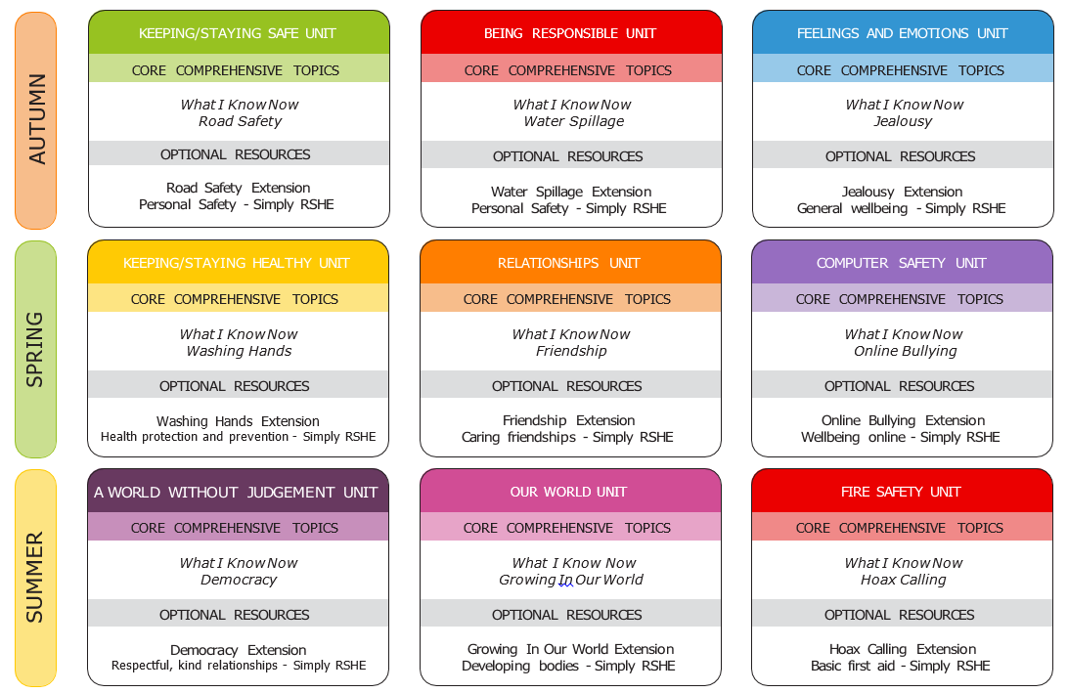
Year 1
Year 2
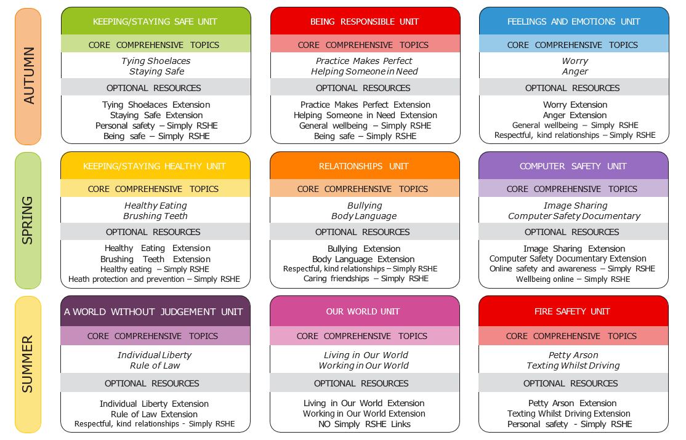
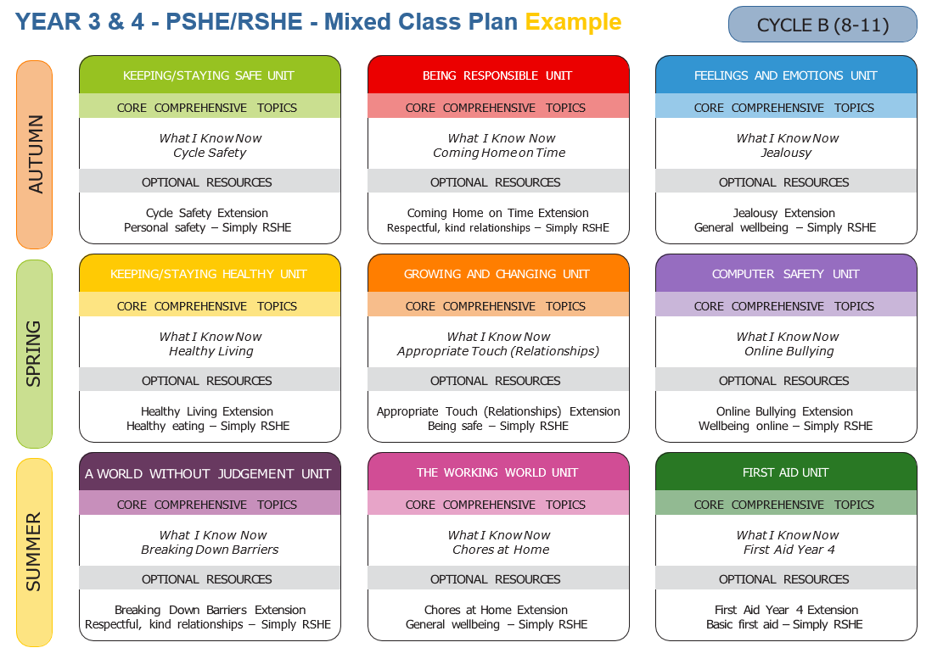
Year 3/4 Class (Use Cycle B for 2026 - 27)

Year 4/5 Class (Use Cycle A for 2026 - 27)
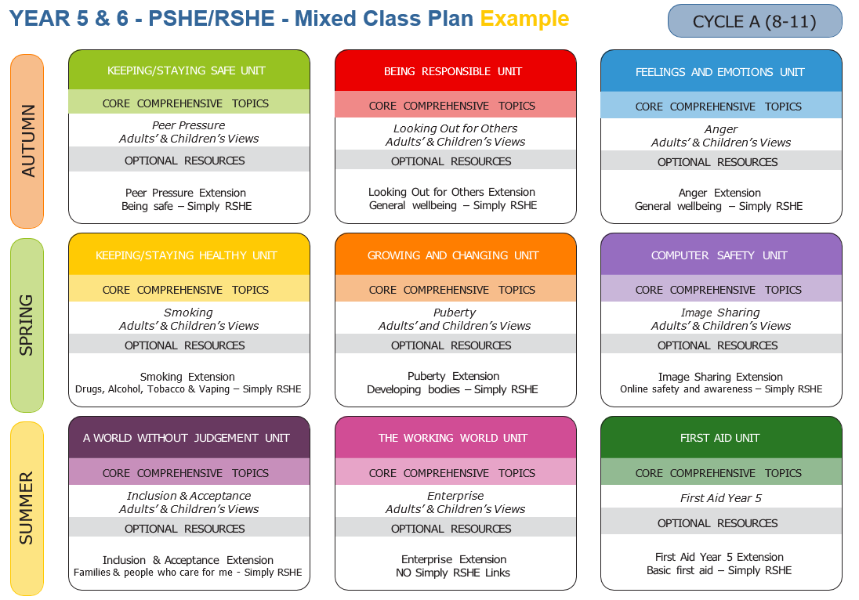

Year 6
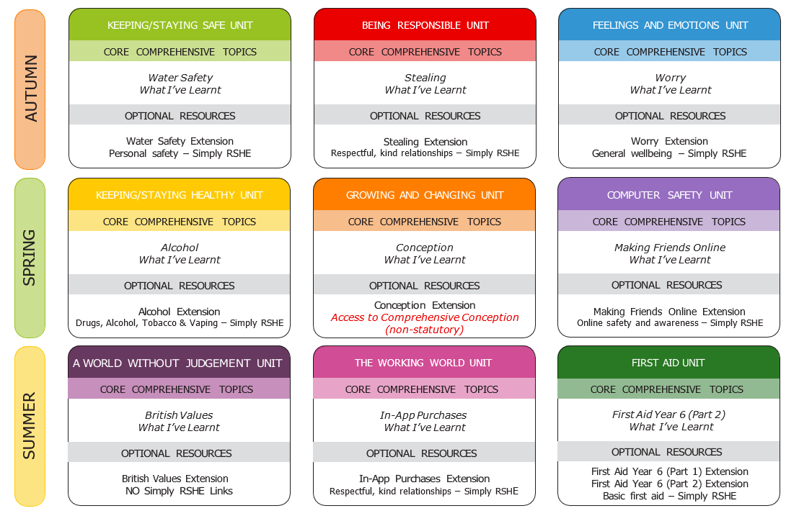
Units to be covered every term by each year group with the knowledge and skills objectives:

 | Autumn | Spring | Summer
Robins  (Year 1) | UNIT: Keeping / Staying Safe  Topics:  - Long-Term Assessment - Baseline Topic  - Road Safety  • share their existing ideas about how to stay safe in different environments  • begin to recognise situations that may involve risk  • identify safe and unsafe choices in everyday scenarios  • suggest simple strategies that can help keep themselves and others safe  • understand why it is important to stay safe when crossing the road  • recognise a range of safe places to cross the road  • understand the differences between safe and risky choices  • know different ways to help us stay safe  UNIT: Being Responsible  Topics:  - Long-Term Assessment - Baseline Topic  - Water Spillage  • share their existing ideas about what they can do for themselves and what they are responsible for  • begin to recognise responsibilities they have at home and at school  • identify ways their responsibilities may change as they grow and become more independent  • suggest who can help and support them when they need guidance or assistance  • explain how you can help people around you  • understand the types of things you are responsible for  • know how and understand the importance of preventing accidents  • recognise the differences between being responsible and being irresponsible  UNIT: Feelings and Emotions  Topics:  - Long-Term Assessment - Baseline Topic  - Jealousy  • share their existing ideas about different feelings and emotions they may experience  • begin to recognise situations that may cause different feelings  • identify a range of feelings in everyday situations  • suggest simple ways they and others can express and manage their emotions  • identify and name difficult feelings, such as jealousy, and describe some physical signs they may notice  • know that these feelings are normal and begin to recognise helpful and unhelpful ways of showing them  • learn and practise simple strategies to manage difficult feelings in positive ways  • recognise that feelings can be shown through words, actions and body language | UNIT: Keeping / Staying Healthy  Topics:  - Long-Term Assessment - Baseline Topic  - Washing Hands  • share their existing ideas about what helps people stay healthy  • begin to recognise choices that help keep their bodies healthy  • identify healthy and less healthy choices in everyday situations  • suggest simple habits that help keep themselves and others healthy  • understand why it is important to wash our hands  • explain how germs spread and how they affect our health  • demonstrate correct handwashing technique  • begin to identify healthy and unhealthy choices  UNIT: Relationships  Topics:  - Long-Term Assessment - Baseline Topic  - Friendship  • share their existing ideas about how people can treat others kindly and respectfully  • begin to recognise behaviours that help build positive relationships  • identify kind and unkind behaviours in everyday situations  • suggest simple ways they can show kindness and respect to others  • explain how to be a good friend  • recognise kind and thoughtful behaviours  • understand the importance of caring about other people’s feelings  • be able to see a situation from another person’s point of view  UNIT: Computer Safety  Topics:  - Long-Term Assessment - Baseline Topic  - Online Bullying  • share their ideas about using computers and the internet  • begin to recognise when something online may not be safe  • identify safe and unsafe choices when using technology  • suggest ways to stay safe online and ask an adult for help  • understand how your online actions can affect others  • identify the positives and negatives of using technology  • know who and how to ask for help  • recognise kind and unkind comments | UNIT: Our World  Topics:  - Long-Term Assessment - Baseline Topic  - Growing in Our World  • share their existing ideas about what lives and grows in our world  • begin to recognise that people, animals and plants need care to grow and stay healthy  • identify who helped to look after them when they were babies  • suggest simple ways they are learning to look after themselves as they grow  • understand the needs of a baby  • explain what you can do for yourself now you are older  • describe the common features of family life  • recognise the ways in which your family is special and unique  UNIT: Fire Safety  Topics:  - Long-Term Assessment - Baseline Topic  - Hoax Calling  • share their existing ideas about how people stay safe and who helps keep us safe in our community  • begin to recognise situations that may be emergencies or unsafe  • identify emergency services, such as the Fire Service, and understand how they help people  • suggest simple actions that help keep themselves and others safe in everyday situations  • understand the importance of being responsible and how our actions/ choices can affect others  • know what a ‘hoax call’ is and why it can be risky  • explain why our emergency services are an important part of our community  • show my knowledge of fire safety to others  UNIT: A World Without Judgement  Topics:  - Long-Term Assessment - Baseline Topic  - Democracy  • share their existing ideas about rules, fairness and how we treat others kindly  • begin to recognise why rules help keep classrooms and communities fair and safe  • identify ways they can show kindness, respect and fairness to others  • suggest simple ways they can make positive choices and help everyone feel included  • understand what a democracy is  • spot times when people vote or choose things together  • know that people can think differently  • talk about ways to make fair choices when we do not agree
Sparrows  (Year 2) | UNIT: Keeping / Staying Safe  Topics:  - Tying Shoelaces  - Staying Safe  • know the reasons to make sure your laces are tied  • learn how to tie up laces properly  • know rules to keep yourself and others safe  • understand the differences between safe and risky choices  • know ways to keep yourself and others safe  • recognise risky situations  • identify trusted adults around you  • understand the differences between safe and risky choices  UNIT: Being Responsible  Topics:  - Practise Makes Perfect  - Helping Someone in Need  • name ways you can improve in an activity or sport  • understand the importance of trying hard and not giving up  • recognise the benefits of practising an activity or sport  • learn how to set goals and work to reach them  • know how you can help other people  • recognise kind and thoughtful behaviours and actions  • understand the risks of talking to people you don’t know very well in the community  • identify the differences between being responsible and being irresponsible  UNIT: Feelings and Emotions  Topics:  - Worry  - Anger  • identify and name feelings of worry and describe some physical signs they may experience  • understand that worry is a normal emotion and identify situations that may cause someone to feel worried  • learn and practise strategies to manage feelings of worry in positive ways  • explain that feelings of worry can be communicated through words, actions and body language  • identify and name feelings of anger and describe some physical signs they may experience  • understand that anger is a normal emotion and distinguish between helpful and unhelpful ways of expressing it  • learn and practise strategies to manage feelings of anger in positive ways  • explain that anger can be communicated through words, actions and body language | UNIT: Keeping / Staying Healthy  Topics:  - Healthy Eating  - Brushing Teeth  • know that different foods help our bodies to stay healthy and grow strong  • understand why some foods are healthier than others  • be able to explain ways to keep healthy  • recognise and begin to make healthy choices  • understand why it is important to brush our teeth  • demonstrate how to brush our teeth properly  • suggest ways to remember to brush teeth when we forget, are tired, or busy  • recognise and begin to make healthy choices  UNIT: Relationships  Topics:  - Bullying  - Body Language  • name a range of feelings  • understand why we should care about other people’s feelings  • be able to see and understand bullying behaviours  • know how to cope with these bullying behaviours  • recognise and name a range of feelings  • understand that feelings can be shown without words  • be able to see a situation from another person’s point of view  • explain why it is important to care about other people’s feelings  UNIT: Computer Safety  Topics:  - Image Sharing  - Computer Safety Documentary  • identify the positives and negatives of using technology  • know who and how to ask for help  • list rules for keeping and staying safe  • understand how your online activity can affect others  • recognise that we should not share personal information online  • understand that we should be kind and respectful when using technology  • identify when it is important to ask a trusted adult before downloading apps or sharing images  • explain that people online may not always be who they say they are | UNIT: A World Without Judgement  Topics:  - Individual Liberty  - Rule of Law  • understand that people can make their own choices and that these choices may be different from others  • explain why it is important that everyone can make safe choices  • recognise ways to respect the choices of others while making responsible choices themselves  • identify their own strengths, interests and goals, understanding that these may be different from those around them  • explain how rules help groups work and learn together at home, at school and in the community  • understand why rules are important in helping people stay safe and treat others fairly  • identify examples of rules that people follow in everyday life  • recognise that rules apply to everyone and help people make fair and responsible choices  UNIT: Our World  Topics:  - Living in Our World  - Working in Our World  • understand why we should look after living things  • identify how we can look after living things both inside and outside of the home  • recognise why it is important to keep our communities and countryside clean  • encourage others to help keep their communities and countryside clean  • understand different ways we can receive money  • know how to keep money safe  • describe the skills you may need in a future job or career  • recognise the differences between wants and needs  UNIT: Fire Safety  Topics:  - Petty Arson  - Texting Whilst Driving  • understand the importance of being responsible and how our actions/choices can affect others  • practise simple ways of staying safe and finding help  • know that even small fires can be very dangerous  • identify the differences between safe and risky choices  • understand how our actions and choices can affect others  • recognise how drivers can be distracted  • know how to help others stay safe  • describe the differences between safe and risky choices
Woodpeckers  (Year 3/4)  USE ‘YEAR 3 & 4 MIXED CLASS PLAN’  CYCLE B | UNIT: Keeping / Staying Safe  Topics:  - What I Know Now  - Cycle Safety  • share and reflect on their understanding of how to stay safe as they begin to explore more complex safety topics  • recognise situations that may place themselves or others at risk  • identify trusted people and support that can help them stay safe  • suggest and explain safe actions in a range of everyday situations  • identify strategies we can use to keep ourselves and others safe  • recognise the impact and possible consequences of an accident or incident  • identify what is a risky choice  • create a set of rules for and identify ways of keeping safe  UNIT: Being Responsible  Topics:  - What I Know Now  - Coming Home on Time  • share and reflect on their understanding of what it means to be responsible as they begin to explore more complex aspects of responsibility  • recognise situations where responsible choices and actions are needed and consider the positive impact these actions can have  • identify people and support who can help guide them in making responsible decisions  • suggest and explain ways they can act responsibly in a range of everyday situations and how these actions can benefit others  • recognise the importance of behaving in a responsible manner in a range of situations  • describe a range of situations where being on time is important  • explain the importance of having rules in the home  • describe ways that behaviour can be seen to be sensible and responsible  UNIT: Feelings and Emotions  Topics:  - What I Know Now  - Jealousy  • share and reflect on their understanding of feelings and emotions as they begin to explore more complex emotional experiences  • recognise situations that may cause different emotions for themselves or others  • identify people and support who can help them manage difficult or uncomfortable emotions  • suggest and explain strategies that can help them express and manage their feelings in positive ways  • identify and name difficult emotions, such as jealousy, and describe some physical signs they may experience  • understand that difficult emotions are a normal part of life and distinguish between helpful and unhelpful ways of expressing them  • learn and practise strategies to manage challenging emotions in positive ways  • explain that emotions can be communicated through words, actions and body language | UNIT: Keeping / Staying Healthy  Topics:  - What I Know Now  - Healthy Living  • share and reflect on their understanding of how to keep their bodies healthy as they begin to explore more complex health topics  • recognise choices and behaviours that can affect their health and wellbeing  • identify people and support who can help them stay healthy and make positive choices  • suggest and explain healthy habits that support physical and personal wellbeing in everyday life  • explain what is meant by a balanced diet and plan a balanced meal  • recognise how too much sugar, salt, and saturated fat in our food and drink can affect us now and when we are older  • understand nutritional information on packaged food and explain what it means  • describe different ways to maintain a healthy lifestyle  UNIT: Growing & Changing  Topics:  - What I Know Now  - Appropriate Touch (Relationships)  • share and reflect on their understanding of positive relationships as they begin to explore more complex relationship topics  • recognise behaviours and situations that may affect relationships or cause others to feel upset  • identify trusted people and support who can help them manage relationship difficulties or worries  • suggest and explain ways to show respect, kindness and consideration in everyday relationships  • recognise the different types of relationships we can have and describe how these can change as we grow  • explain how our families support us and how we can support our families  • identify how relationships can be healthy or unhealthy  • explain how to ask for help and identify who can help us if a relationship makes us feel uncomfortable  UNIT: Computer Safety  Topics:  - What I Know Now  - Online Bullying  • share and reflect on their understanding of how to stay safe when using technology as they begin to explore more complex online safety topics  • recognise situations that may place themselves or others at risk when using technology or communicating online  • identify trusted people and support who can help them if something online or on a device worries them  • suggest and explain safe actions that help them use technology responsibly in everyday situations  • recognise the key values that are important in positive online relationships  • explain the feelings and emotions that may arise from online bullying  • develop coping strategies to use if we or someone we know is being bullied online  • identify how and who to ask for help | UNIT: A World Without Judgement  Topics:  - What I Know Now  - Breaking Down Barriers  • share and reflect on their understanding of how communities work together as they begin to explore ideas about judgement and fairness  • recognise situations where unfair judgement or discrimination may affect individuals or groups  • identify people and groups that help support fairness and respect within communities  • suggest and explain ways they can show respect for themselves and others and help create inclusive communities  • recognise positive attributes in others  • explain why being different is okay  • explore your own strengths and goals, and understand that these may be different from those around you  • identify some of the ways we can overcome barriers and promote equality  UNIT: The Working World  Topics:  - What I Know Now  - Chores at Home  • share and reflect on their understanding of how people support their families, communities and wider society  • recognise responsibilities they may have at home and how helping with everyday tasks contributes to family life  • identify skills and qualities that may be useful in different jobs and roles people do  • suggest and explain simple ways money is used, earned and saved in everyday life  • recognise ways in which we can help those who look after us  • explain the positive impact of our actions  • describe the ways in which we can contribute to our home, school, and community  • identify the skills we may need in our future job roles  UNIT: First Aid  Topics:  - What I Know Now  - First Aid Year 4  • share and reflect on their understanding of how people can help in medical emergencies as they begin to explore first aid topics  • recognise situations where someone may need help due to illness, injury or breathing difficulties  • identify trusted adults and emergency services who can provide help and support in an emergency  • suggest and explain simple actions that can help keep someone safe until help arrives  • identify and name situations that may require first aid  • list reasons why someone may struggle to breathe  • recognise the signs of an asthma attack or choking  • identify the signs of an allergic reaction and anaphylactic shock  • understand the correct steps for seeking immediate emergency help  • provide first aid treatment to someone who is struggling to breathe
(Year 4/5)  USE ‘YEAR 5 & 6 MIXED CLASS PLAN’  CYCLE A | UNIT: Keeping / Staying Safe  Topics:  - Peer Pressure  - Adults’ & Children’s Views  • identify strategies we can use to keep ourselves and others safe  • understand ways to manage peer pressure  • explain the potential outcomes that may happen when we take risks  • recognise the impact and possible consequences of an accident or incident  • listen to and observe a range of views from adults and children about how to stay safe and ask for help  • identify key ideas and strategies shared by others that help people manage risks and stay safe  • reflect on and build their own understanding of safety using information gathered from discussions and observations  • share their ideas and learning with peers, contributing thoughtfully to discussions about staying safe  UNIT: Being Responsible  Topics:  - Looking Out for Others  - Adults’ & Children’s Views  • recognise why we should take action when someone is being unkind  • describe caring and considerate behaviour, including the importance of looking out for others  • demonstrate why it is important to behave in an appropriate and responsible way  • identify how making some choices can impact others’ lives in a negative way  • listen to and observe a range of views from adults and children about what it means to act responsibly in different situations  • identify key ideas and strategies shared by others that help people make responsible choices and support those around them  • reflect on and build their own understanding of responsibility using information gathered from discussions and observations  • share their ideas and learning with peers, contributing thoughtfully to discussions about acting responsibly and supporting others  UNIT: Feelings and Emotions  Topics:  - Anger  - Adults’ & Children’s Views  • recognise triggers that may lead to feelings of anger and describe how anger can affect thoughts, behaviour and physical reactions • explain how anger can influence actions and relationships and evaluate helpful and unhelpful ways of responding  • apply a range of strategies to manage feelings of anger in positive and responsible ways  • reflect on how anger can be communicated and managed through words, actions and self-control  • listen to and observe a range of views from adults and children about managing feelings and emotions in different situations  • identify key ideas and strategies shared by others that help people understand and manage their emotions  • reflect on and build their own understanding of emotions using information gathered from discussions and observations  • share their ideas and learning with peers, contributing thoughtfully to discussions about feelings and emotions | UNIT: Keeping / Staying Healthy  Topics:  - Smoking  - Adults’ & Children’s View  • explain some of the risks associated with smoking (physical, social, and legal) and name the addictive ingredient found in cigarettes, e-cigs, etc.  • describe how smoking can affect your immediate and future health and wellbeing  • give reasons why someone might start and continue to smoke  • identify and use skills and strategies to resist any pressure to smoke  • listen to and observe a range of views from adults and children about ways to stay healthy and maintain wellbeing  • identify key ideas and healthy habits shared by others that support physical and personal health  • reflect on and build their understanding of healthy choices using information gathered from discussions and observations  • share their ideas and learning with peers, contributing thoughtfully to discussions about maintaining a healthy lifestyle  UNIT: Growing & Changing  Topics: Year 5s to be taught this unit separately. Year 4s could be taught the Growing and Changing - Appropriate Touch unit from the Year 3/4 mixed age plan Cycle B)  - Puberty  - Adults’ & Children’s Views  • explain what puberty means  • describe the changes that boys and girls may go through during puberty  • identify why our bodies go through puberty  • develop coping strategies to help with the different stages of puberty  • identify who and what can help us during puberty  • listen to and observe a range of views from adults and children about positive relationships and how to seek support when needed  • identify key ideas and strategies shared by others that help people build and maintain healthy relationships  • reflect on and build their own understanding of relationships using information gathered from discussions and observations  • share their ideas and learning with peers, contributing thoughtfully to discussions about respectful and healthy relationships  UNIT: Computer Safety  Topics:  - Image Sharing  - Adults’ & Children’s Views  • list reasons for sharing images online • identify rules to follow when sharing images online  • describe the positive and negative consequences of sharing images online  • recognise possible influences and pressures to share images online  • listen to and observe a range of views from adults and children about staying safe when using technology and the internet  • identify key ideas and strategies shared by others that help people use technology safely and responsibly  • reflect on and build their own understanding of online safety using information gathered from discussions and observations  • share their ideas and learning with peers, contributing thoughtfully to discussions about safe and responsible use of technology | UNIT: A World Without Judgement  Topics:  - Inclusion & Acceptance  - Adults’ & Children’s Views  • identify some of the ways in which we are different and unique  • explain some of the elements which help us to have a diverse community  • describe strategies to overcome barriers and promote diversity and inclusion  • recognise the importance of inclusion and acceptance and identify ways we can help others feel valued and respected  • listen to and observe a range of views from adults and children about respect, equality and inclusion in communities  • identify key ideas and actions shared by others that help challenge judgement and support fairness  • reflect on and build their own understanding of acceptance and inclusion using information gathered from discussions and observations  • share their ideas and learning with peers, contributing thoughtfully to discussions about respecting differences and supporting others  UNIT: The Working World  Topics:  - Enterprise  - Adults’ & Children’s Views  • understand and explain why people might want to save money  • identify ways in which you can help out at home  • budget for items you would like to buy  • recognise ways to make money and the early stages of enterprise  • listen to and observe a range of views from adults and children about how people work, support their families and contribute to society  • identify key ideas and skills shared by others that help people succeed in different jobs and roles  • reflect on and build their own understanding of how money is earned, spent and looked after using information gathered from discussions and observations  • share their ideas and learning with peers, contributing thoughtfully to discussions about future jobs, responsibilities and the role money plays in everyday life  UNIT: First Aid  Topics:  - First Aid Year 5 - Part 1  - First Aid Year 5 - Part 2  • complete a primary survey for first aid • demonstrate the recovery position for an unresponsive breathing casualty  • know when to deliver CPR  • demonstrate how to do CPR  • understand when to call for emergency help  identify a range of situations that may require first aid  • explain how to support someone with a minor or serious head injury  • recognise how to support someone who is having a seizure  • understand how to support someone with a severe bleed  • know when to call for medical help
Owls  (Year 6) | UNIT: Keeping / Staying Safe  Topics:  - Water Safety  - What I’ve Learnt  • identify a range of danger signs  • develop and name strategies that can help keep ourselves and others safe  • recognise the impact and possible consequences of an accident or incident  • confidently apply and justify strategies that help keep themselves and others safe in different environments  • evaluate situations and respond responsibly when they or others may be at risk  • clearly explain and justify the difference between safe and risky choices  • take increasing responsibility for making safe decisions at home, at school and in the community  UNIT: Being Responsible  Topics:  - Stealing  - What I’ve Learnt  • explain what consent means  • recognise the importance of being honest and not stealing  • understand why it is important to have a trusting relationship between friends and family  • identify how making some choices can impact others’ lives in a negative way  • confidently demonstrate and justify responsible behaviours that support themselves and others in different environments  • evaluate situations and respond appropriately when responsible choices are needed  • clearly explain and justify the difference between responsible and irresponsible choices  • take increasing responsibility for their actions and decisions at home, at school and in the community  UNIT: Feelings and Emotions  Topics:  - Worry  - What I’ve Learnt  • recognise situations that may cause feelings of worry, including changes and new experiences such as moving to secondary school  • explain how worry can affect thoughts, behaviour and physical responses and why it is a normal emotion during times of change  • apply a range of strategies to manage feelings of worry in positive and responsible ways during challenging or unfamiliar situations  • reflect on ways to communicate worries and seek support from trusted people when preparing for new experiences such as secondary school  • confidently apply and justify strategies that help them manage and express their emotions in positive and responsible ways  • evaluate situations and respond appropriately when emotions may affect their behaviour or relationships  • clearly explain and justify the difference between helpful and unhelpful ways of expressing emotions  • take increasing responsibility for managing their feelings and supporting the emotional wellbeing of themselves and others | UNIT: Keeping / Staying Healthy  Topics:  - Alcohol  - What I’ve Learnt  • identify what is a risky choice  • explain the risks associated with alcohol  • describe how alcohol can affect your immediate and future health develop and recognise skills and strategies to keep safe  • confidently apply and justify healthy choices that support their own health and wellbeing  • evaluate situations and influences that may affect their health and respond responsibly  • clearly explain and justify the difference between healthy and unhealthy choices  • take increasing responsibility for maintaining healthy habits and supporting the wellbeing of themselves and others  UNIT: Growing & Changing  Topics:  - Conception  - What I’ve Learnt  • explain the terms ‘conception’ and ‘reproduction’  • describe the function of the female and male reproductive systems  • identify the various ways adults can have a child  • explore various different stages of pregnancy  • understand the laws around consent  • confidently demonstrate and justify behaviours that support positive, respectful and healthy relationships  • evaluate situations and respond responsibly when relationships or interactions may cause upset, discomfort or harm  • clearly explain and justify the difference between healthy and unhealthy relationship behaviours  • take increasing responsibility for maintaining respectful relationships and supporting the wellbeing of themselves and others  UNIT: Computer Safety  Topics:  - Making Friends Online  - What I’ve Learnt  • list the key applications that we may use now and in the future  • know and understand why some applications have age restrictions  • identify ways to keep yourself and others safe in a range of situations online and offline  • recognise that people may not always be who they say they are online  • confidently apply and justify strategies that help them use technology safely and responsibly in different environments  • evaluate online situations and respond appropriately when they or others may be at risk or feel pressured to share information or images  • clearly explain and justify the difference between safe and risky choices when using technology and communicating online  • take increasing responsibility for making safe and respectful decisions when using devices at home, at school and in the wider community | UNIT: A World Without Judgement  Topics:  - British Values  - What I’ve Learnt  • understand that there are a wide range of religions and beliefs in the UK  • describe each of the British values  • create a range of values for your educational setting  • explain how all religions can live in cohesion  • confidently demonstrate and justify respectful behaviours that support fairness, equality and inclusion in different environments  • evaluate situations and respond responsibly when people’s beliefs, values or backgrounds may be treated unfairly  • clearly explain and justify the importance of British values, including respect for different religions and beliefs  • take increasing responsibility for promoting respect, tolerance and cohesion within their school and wider community  UNIT: The Working World  Topics:  - In-App Purchases  - What I’ve Learnt  • know and understand various money-related terms • recognise some of the ways in which we can spend money via technology  • describe the potential impact of spending money without permission  • identify strategies to save money  • confidently apply and justify responsible decisions when managing money and considering spending choices in everyday and online situations  • evaluate situations and respond appropriately when spending, saving or making purchases that may affect themselves or their household  • clearly explain and justify the difference between responsible and irresponsible choices when using money, including online and in-app purchases  • take increasing responsibility for understanding how work, earning, saving and spending money can affect individuals, families and communities  UNIT: First Aid  Topics:  - First Aid Year 6 (Part 2)  - What I’ve Learnt  • identify a range of situations that may require first aid  • recognise how to support someone with a minor burn or scald  • explain how to support someone who is having a heart attack  • understand how to support someone with a fractured bone  • know when to call for medical help  • confidently apply and justify first aid strategies that help keep themselves and others safe in a range of emergency situations  • evaluate situations and respond appropriately when someone may require first aid or urgent medical support  • clearly explain and justify appropriate first aid responses for injuries or illnesses such as burns, fractures or suspected heart attacks  • take increasing responsibility for recognising when to seek medical help and supporting others safely until help arrives

