2026-27
Using the Purple Mash website, children will learn about the following:
Online Safety is taught through 2BeSafe scheme from Wrens to Owls.
Wrens
Access to range of IT equipment:  Recognise that a range of technology is used in places in and out of school  Select and use technology for particular purposes | Beebots  Use Beebots to understand how to follow and create specific instructions.  Create and debug simple programs using beebots.  Use logical reasoning to predict the behaviour of a Beebot | Appropriate use of equipment  Understand how to use the ipads and the interactive whiteboard appropriately, safely and respectfully. | Resources required:  Ipads  Beebots  Interactive whiteboard  Cameras  Photocopier  CD players  Keyboard  Torches  Battery operated devices  Phones

Robins
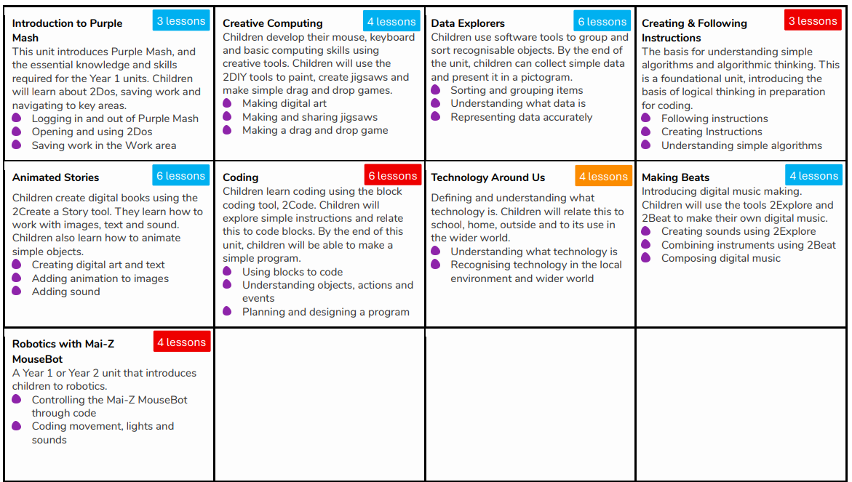

Sparrows
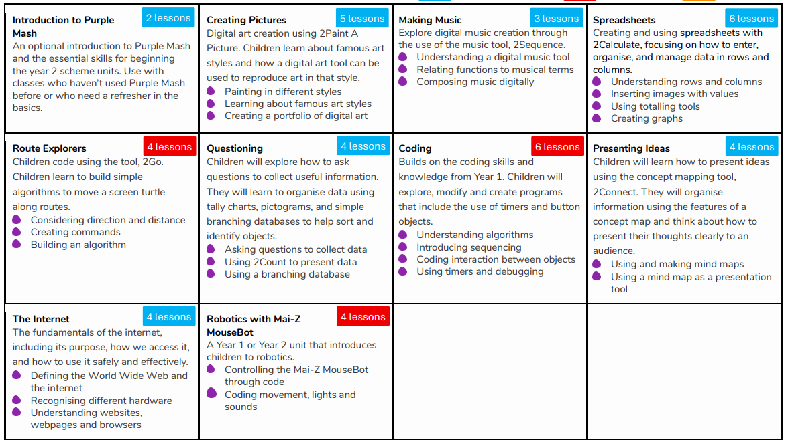

Woodpeckers (Y4 planning)
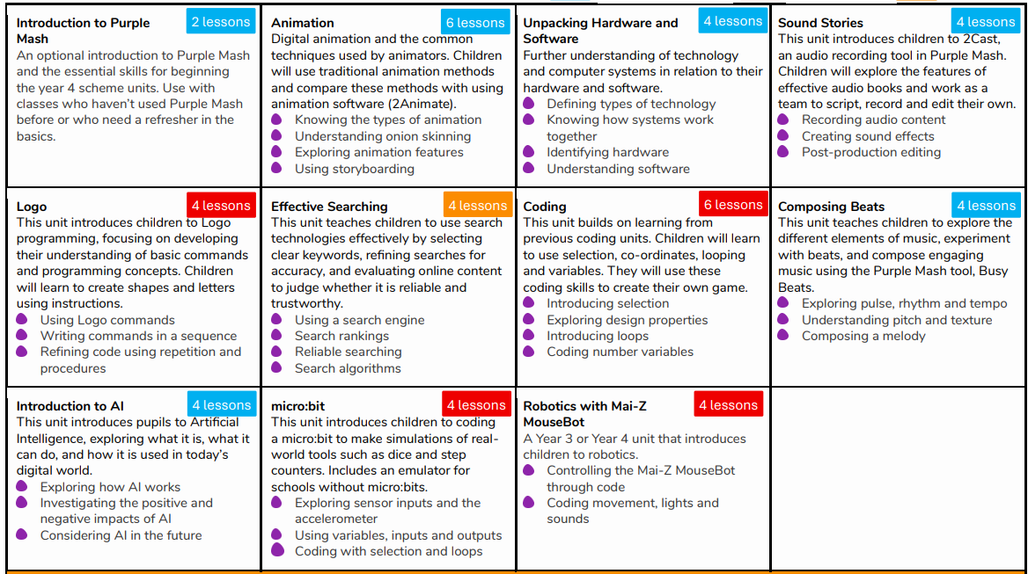

Starlings (Y5 planning)
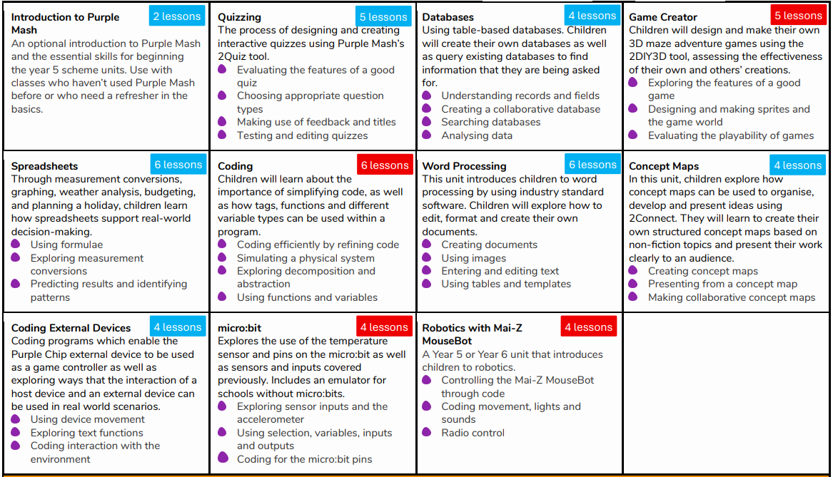

Owls 

